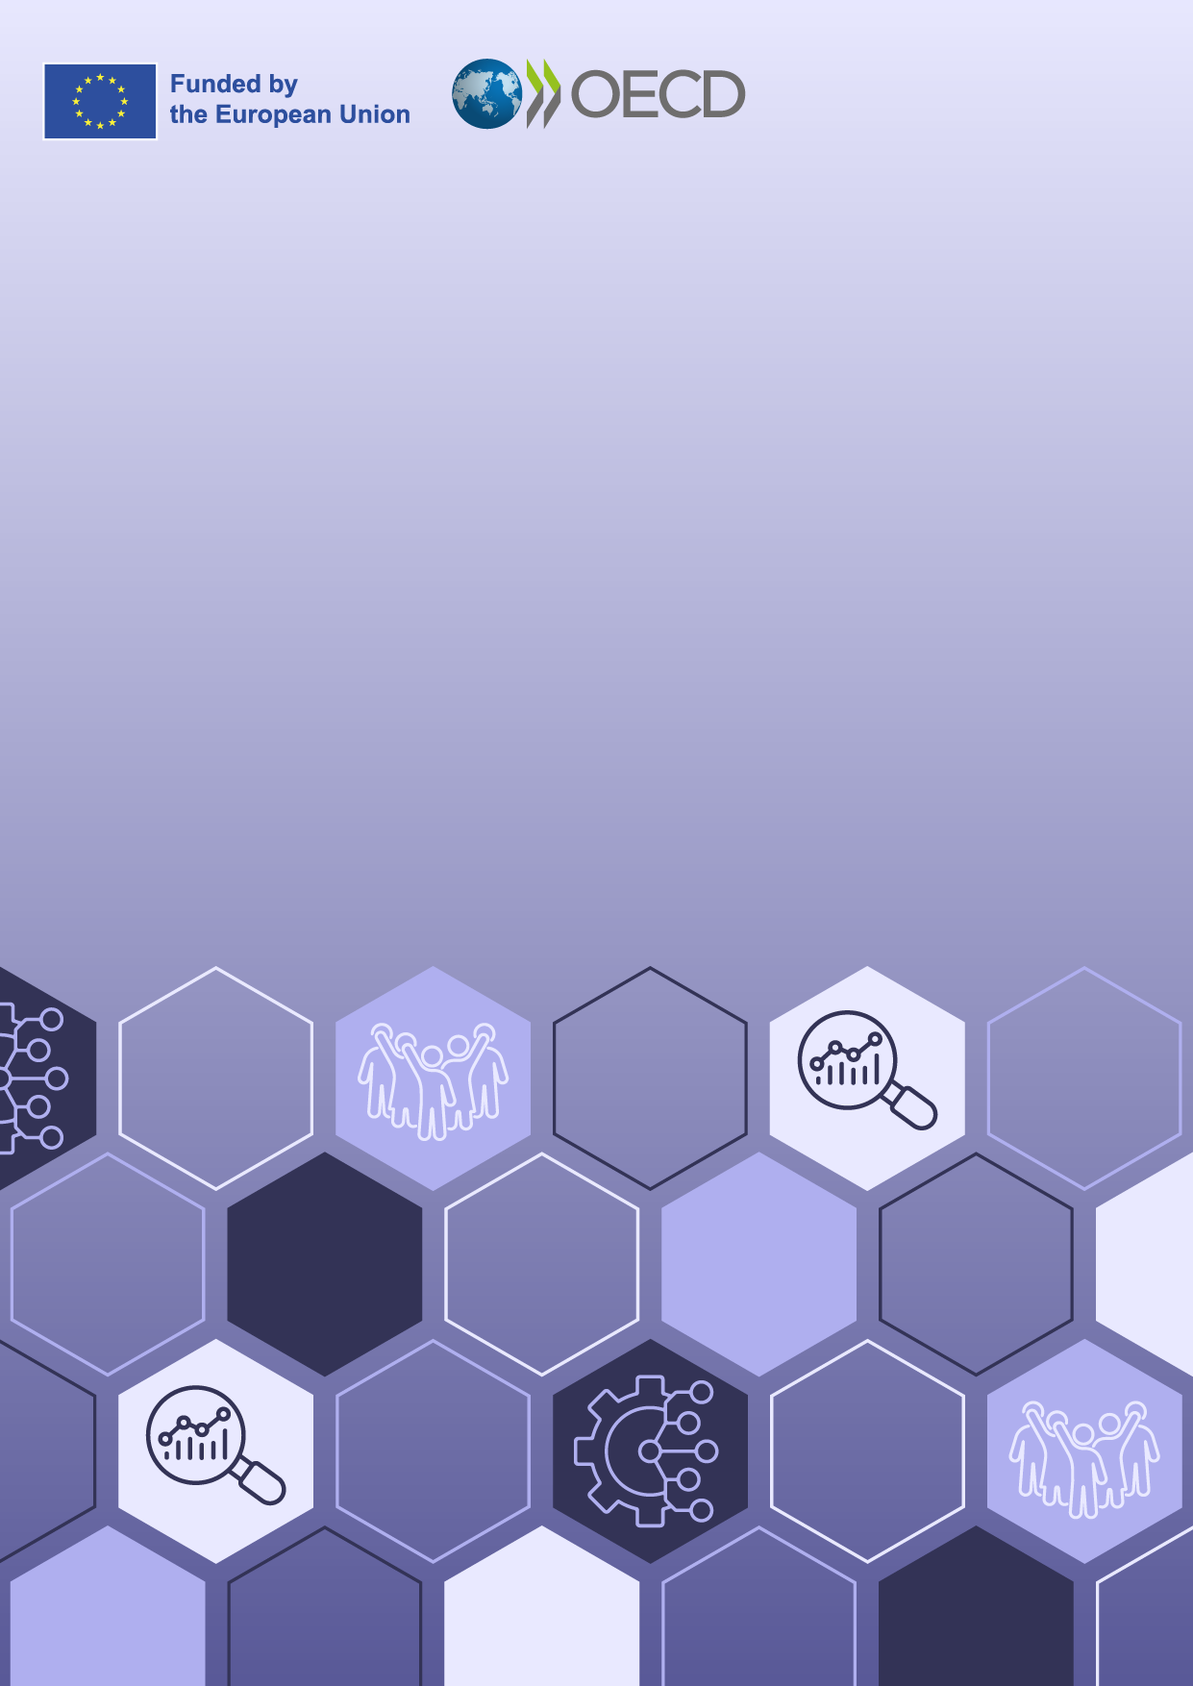

Enhancing Access to Justice through
People-Centred Justice in Malta
Diagnosis report

Multi-country project
24IE07 | 24IT38 | 24MT03 | 24NL05
​Enhancing Access to Justice Through People-Centred Justice

1. Understanding people’s legal needs and justice problems
Justice systems are at their strongest when they reflect the needs of the people they serve. Similar to other countries, in Malta justice problems arise frequently in people’s lives: at home, at work, and within their communities. These issues concern people’s health, livelihoods, and relationships; they involve interactions with public services, businesses, neighbors, employers.
To identify the justice problems people encounter in their lives, how they attempt to address these problems, and the pathways they follow in seeking resolution, the World Justice Project’s EUROVOICES General Population Poll was conducted in Malta. The survey reached 500 people across the country, capturing their experiences as they navigated justice problems, sought information and advice, engaged with formal or information mechanisms, and attempted to resolve their problems. Importantly, the data does not directly reflect the performance of individual courts or justice actors. The survey was administered face-to-face between 2 January and 13 March 2024. Survey respondents had the option to either answer the survey in Maltese or English. More information on the survey design, sampling strategy, and data collection process can be found in the Annex.
People’s experiences with the justice system in Malta highlight how individuals encounter legal and justice problems in their everyday lives, including the types of issues involved, their prevalence, and the ways in which these problems tend to cluster and reinforce one another. They point to the consequences that arise when legal needs are unmet or when problems remain unresolved, including the human, economic, and social impacts that can follow. Taken together, these patterns enable a holistic understanding of legal needs and justice problems in Malta, grounded in people’s experience.

Encountering justice problems in Malta
Understanding how people in Malta experience justice problems requires examining not only how widespread these issues are, but also who is most affected, the nature of the problems encountered, and the extent to which they occur together. The findings suggest that justice problems are common, interlinked, and unevenly distributed across the population. These patterns suggest a combination of structural, socioeconomic, and demographic factors, all of which could help explain why certain groups face greater obstacles in managing their legal needs and resolving their problems and disputes.

Prevalence of serious justice problems
Justice problems are a common part of everyday life. In Malta, almost half of the people (47%) experienced at least one serious justice problem in the two-year reference period captured by the survey. This prevalence places Malta slightly below the average of the EU Member States (49%), suggesting that people face serious justice problems slightly less often than their counterparts in other EU countries (WJP, 2024_{[2]}).
The reported justice problems arise across a variety of areas: people most often face issues related to consumer protection (23%), public services (16%), land (12%), money and debt (10%), problems linked to their community (10%), employment (8%), and family issues (7%) (WJP, 2024_{[2]}). The fact that these issues arise so widely, demonstrates the need for justice systems and public institutions to be able to respond to broad spectrum of problems, many emerging from ordinary interactions in everyday life. People’s perceptions of why these problems arise provide further insights about the nature of problems. The most frequently cited cause is that the problems are simply part of life (24%), followed by problems caused by bureaucracy (17%). The percentage of problems caused by bureaucracy indicates that procedural and administrative complexity, along with institutional inefficiencies, are seen as primary drivers of justice problems. (WJP, 2024_{[2]})
Figure 1.1. Prevalence of serious justice problems in Malta, by problem category
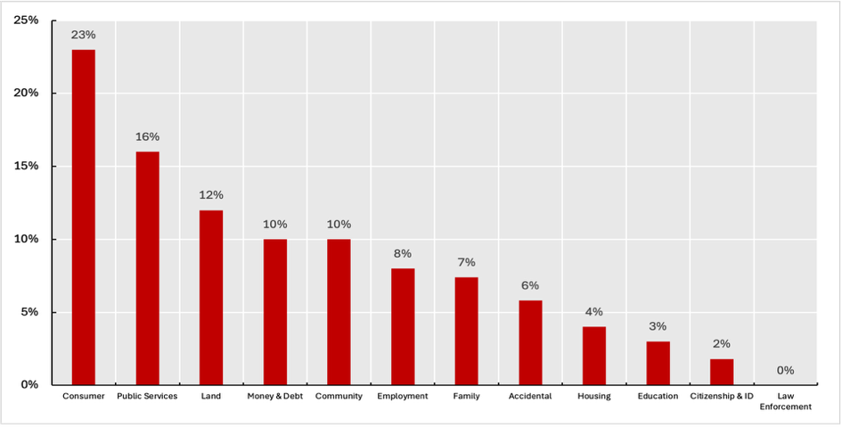
Note: Percentage of respondents who experienced at least one serious justice problem in the past two years by problem category. Data are rounded to the nearest whole number
Source: (WJP, 2024_{[2]})
Although justice problems are widespread and affect all parts of society, there are disparities across sociodemographic groups. Acknowledging these disparities contributes to a more granular understanding of the prevalence of justice problems within society, and can consequently support the design of justice services that are tailored to the needs of specific groups. Men experience serious justice problems at higher rates than women (48% compared to 45%). Prevalence is also significantly higher among people aged 18-24 (57%) and 35-44 (64%) than among those aged 25-34 (36%) and 65 years or more (36%). Individuals facing financial constraints likewise experience more serious justice problems (56%) than those in financially unconstrained situations (45%) (WJP, 2024_{[2]}). Taken together, the higher incidence of serious justice problems within these groups suggests broader socioeconomic inequalities that both intensify existing difficulties and place additional pressures on the well-being of those affected.
Figure 1.2 Prevalence of serious justice problems in Malta
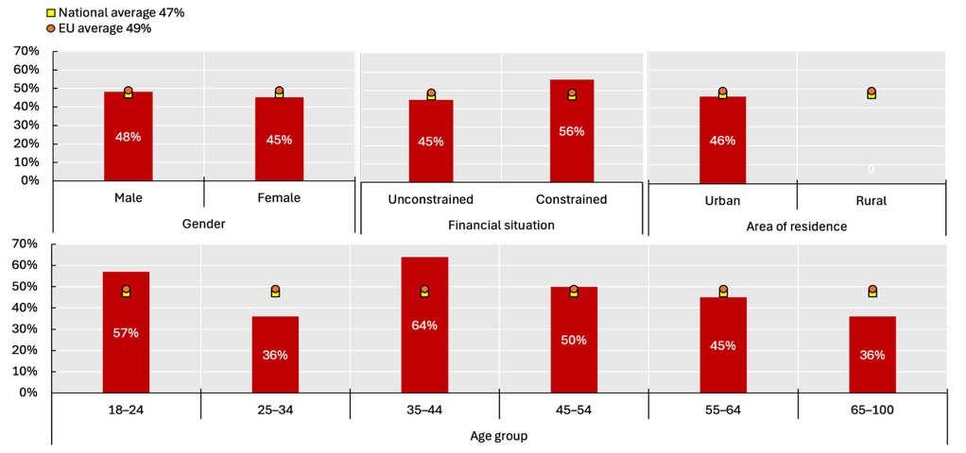
Note: Percentage of respondents who experienced at least one serious problem in the past two years, meaning a problem of self-reported seriousness of 4 or more on a scale of 0 to 10. Data are rounded to the nearest whole number.
Source: (WJP, 2024_{[2]})

Co-occurrence of serious justice problems
People who encounter serious justice problems often face several problems concurrently. On average, people with at least one serious problem deal with around 2.8 issues simultaneously over the two-year reference period. The burden is notably higher among people aged 35-44 and 25-34, who face an average of 2.9 and 3.3 justice problems respectively, in contrast to those aged 65 and above, whose average is 1.8 during the same period. This relatively high degree of co-occurrence suggests that justice difficulties tend to accumulate, with one problem often reinforcing or triggering others (WJP, 2024_{[2]}).

Figure 1.3. Co-occurrence of serious justice problems in Malta
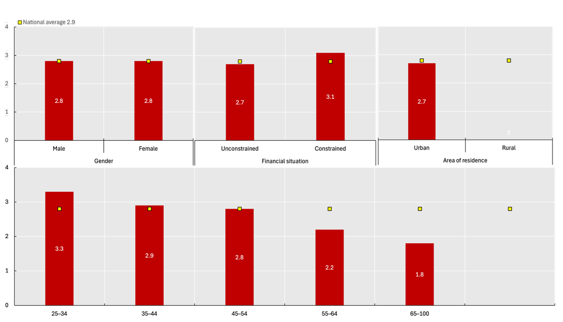
Note: Number of serious justice problems experienced concurrently by a single person in the past two years (occurring during the same period).
Source: (WJP, 2024_{[2]})

Steps in people’s justice pathways
Understanding how people address their problems is essential to assessing the accessibility, fairness, and effectiveness of justice systems. Individuals rarely experience justice as a single event. Instead, they navigate a pathway of interactions and experiences: from seeking information, to obtaining assistance, to engaging formal or informal dispute resolution mechanisms, and ultimately reaching an outcome. Throughout this pathway, personal circumstances, the nature of the problem, and the broader institutional environment shape people’s experiences and opportunities.

Access to information and advice
Access to information and advice can be a first step when attempting to resolve everyday problems. In Malta, 77% of those who encountered a serious justice issue in the previous two years report being able to identify a reliable source of information and advice about resolving their problem. This is well above the EU average (61%) and makes Malta the country with the highest access rate to information and advice among EU Member states (WJP, 2024_{[2]}).
In Malta, access to information and advice differs across sociodemographic groups. Men more frequently state they know where to obtain trustworthy information than women (79% compared to 75%). Interestingly, people who struggle to cover basic needs are more likely to access information (81%) than those without financial constraints (76%). In addition, the number of co-occurring justice problems is associated with better access to information and advice. People dealing with four or more problems are able to obtain help more often than those facing a single issue (81% compared to 72%) (WJP, 2024_{[2]}). Although the survey does not provide explanations for these findings, one possible reason is that people experiencing financial hardship or multiple issues simultaneously are more likely to come into contact with justice or social service providers.
Despite these relatively high levels of access among those directly experiencing justice problems, public trust in the system remains limited. While a substantial share of people facing a serious issue are able to obtain guidance (77%), only 60% in the broader population believe that someone in Malta would know where to turn for information and advice if confronted with a legal difficulty (WJP, 2024_{[2]}). This gap between personal experience and public perception can be linked to a broader challenge: the justice system may function reasonably well for those who actively engage with it, yet it is widely seen as complex, opaque, and difficult to navigate. These findings point to the importance of legal information and support services not only being available but also being accessible and clearly communicated.

Figure 1.4. Access to information and advice in Malta
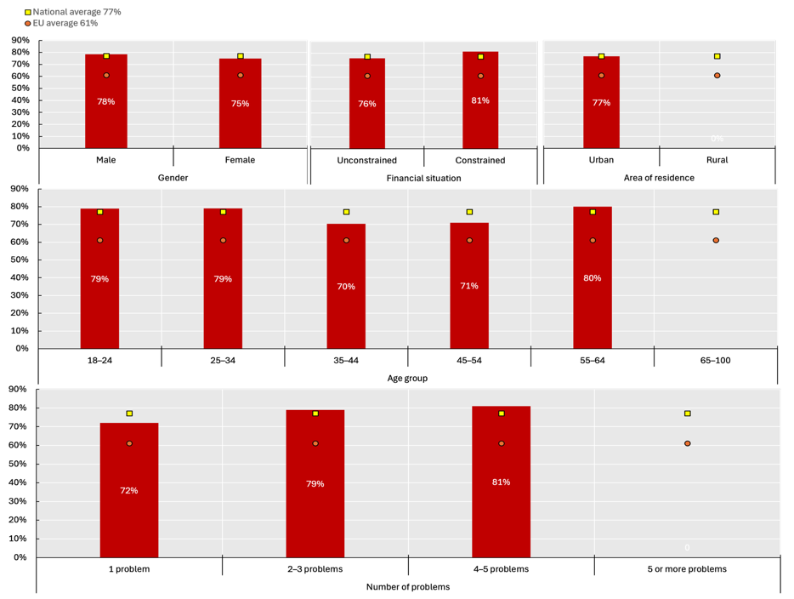
Note: Percentage of respondents who had access to appropriate information and advice out of those who experienced a serious justice problem in the past two years. Data are rounded to the nearest whole number.

Source: (WJP, 2024_{[2]})

Access to assistance and representation
Access to assistance and representation is a central component of how people navigate their justice pathway. Only half (50%) of those who experienced a serious problem attempt to seek advice or representation, while the remaining half does not reach out to anyone. Half did not contact an adviser: 30% of all respondents did not consider assistance necessary, and 20% needed assistance but could not obtain it. Among those who do seek advice, most consult an appropriate advisor (37%), including a lawyer, a professional advisor, an advice service, a government legal aid office, a court or government body, the police, a health or welfare professional, a trade union or employer, a civil society organisation, a religious or community leader, or a friend or relative with a legal background. However, the remaining respondents (13%) tend to rely on a non-professional advisor (e.g. a friend or relative without a legal background, or an unknown person), raising the risk of receiving ineffective or inaccurate information. Combining these pathways, more than half of people in Malta who faced a serious justice problem eventually receive proper assistance and representation (53%). While there remains significant room for improvement, this figure exceeds the EU average (38%), placing Malta as the 1st EU Member state with the highest access rate to assistance and representation in the EU (WJP, 2024_{[2]}).
Disparities appear along economic lines and age. Unlike access to information and advice, those with financial hardship struggle more to obtain appropriate legal help than those without financial constraints (43% compared to 55%). In addition, similar to the trends observed in access to information and advice, people aged 25-34 fare better than those aged 65 years or more (58% compared to 48%), while those facing multiple concurring justice problems (four or five) have a higher degree of access to appropriate assistance than those facing only one justice problem (68% compared to 39%) (WJP, 2024_{[2]}).
When it comes to people’s perceptions and satisfaction, 68% report receiving all the professional assistance they feel they need, indicating that there is still room for improvement. Gender disparities are evident, with 73% of men reporting full satisfaction with the help received, compared to 61% of women. Age differences are also notable: 74% of people aged 65 and over receive all the help they want, compared to 62% of those aged 18-24. These disparities suggest that younger people and women face greater challenges in identifying, affording, or engaging with appropriate experts (WJP, 2024_{[2]}).
As regards the sources of assistance, most people who manage to reach appropriate support turn to a lawyer or professional advisor (65%), and, to a lesser extent, to friends or relatives with a legal background (20%). About four in five people seeking assistance (79%) rely on a single advisor, one in five respondents (21%) consult multiple advisers, reflecting the complexity of navigating appropriate support (WJP, 2024_{[2]}).
Several factors continue to hinder people’s ability to obtain assistance, including financial costs, reluctance to seek help due to previous experiences, fear, distance, not knowing who to contact, or not realising that advice was available. In addition to these practical obstacles, many people perceive legal assistance as largely inaccessible : while 53% of people are actually able to access appropriate assistance, only 43% of the general population believe that people in Malta have access to affordable legal help if they need it (WJP, 2024_{[2]}). Although this perception cannot be directly compared with individual experiences reported in the survey, the justice system appears to be perceived as inaccessible and unaffordable even when the majority of people ultimately succeed in obtaining assistance. Perception was even less positive among women, with only 35% believing that people in Malta have access to affordable legal help, compared with 50% of male respondents. Lower visibility of available services, inconsistent quality, or broader mistrust in institutions may contribute to this perception of limited accessibility.

Figure 1.5. Pathways to accessing appropriate assistance and representation in Malta
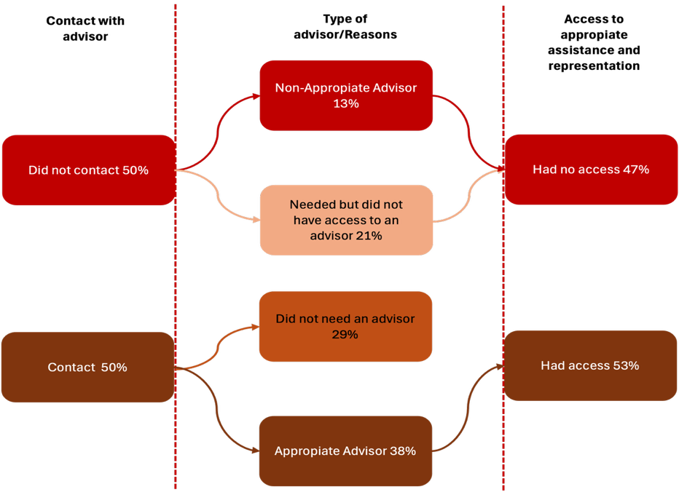
Note: Percentage of respondents who experienced at least one serious justice problem. Percentages shown in the figure sum up to 100% at each stage (i.e., vertically).
Source: (WJP, 2024_{[2]})

Access to dispute resolution mechanisms
Another essential element of justice pathways regards access to dispute resolution mechanisms, including filing a claim in court or with a tribunal, reaching out to the police or another prosecution authority, contacting a government office or designated agency, seeking guidance from a religious authority or community leader, using third-party mediation, engaging a conciliation or arbitration tribunal, or pursuing a formal complaints or appeals process.
In Malta, a relatively small share of people who experienced a serious justice problem contacted a third-party individual or organization to intervene, mediate, or adjudicate (20%). The police is the most frequently approached dispute resolution mechanism (59%), followed by government offices (54%), courts and tribunals (49%), and complaints or appeal offices (46%). Overlapping use of several institutions is common, with 46% contacting three or more institutions, indicating that people rarely rely on a single service or follow a standard pathway (WJP, 2024_{[2]}). As the survey does not provide information on the first step taken by people when accessing a dispute resolution mechanism, collecting further information on justice pathways would be interesting to understand whether overlaps are due to difficulties in finding appropriate services to resolve their problem in a timely manner. Among the 80% of respondents who do not pursue assistance from a third-party individual or an organization, a large portion does not feel the need to turn to a dispute resolution mechanism (60%), while nearly one-quarter (24%) indicate that they need help but are unable to access it. This can be because of the cost, distance, and schedule of available services, belief that the process is too long, bureaucratic complexity, fear of retaliation, lack of knowledge of what to do and where to go, and lack of trust in the authorities (WJP, 2024_{[2]}).
Ultimately, among people who need a dispute resolution mechanism, only 52% succeed in accessing one, pointing to a significant shortfall in access to justice. While this figure exceeds the EU average of 40%, placing Malta first among EU Member states, there is still room to improve nationally. The data also reflects the broader challenge of access to justice across the EU. Gender disparities in access are low, with men reporting a rate of 52% and women 51% (WJP, 2024_{[2]}).
Figure 1.6. Pathways to accessing dispute resolution mechanisms (DRM) in Malta
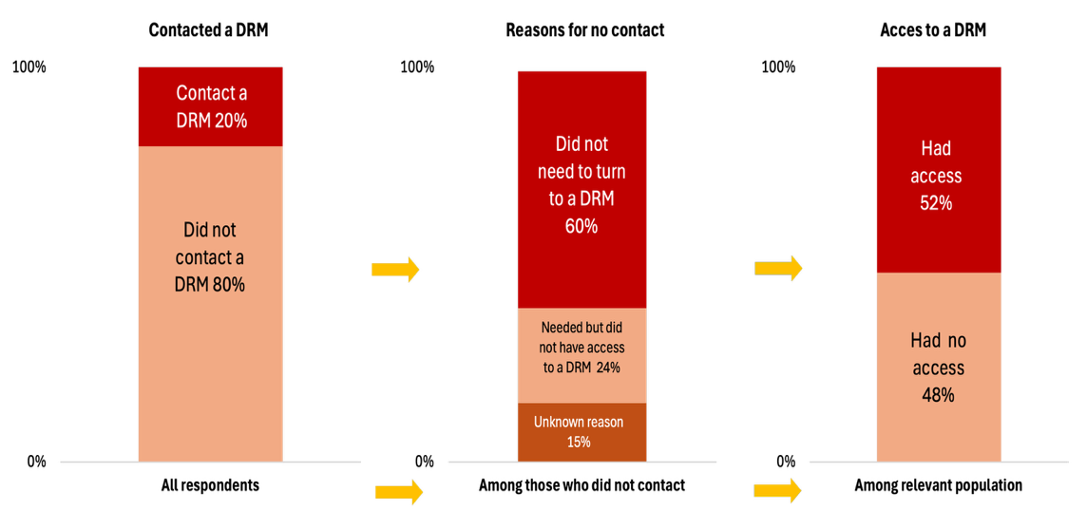
Note: Percentage of respondents who reported a serious justice problem. Percentages shown in the figure sum up to 100% at each stage (i.e. vertically). Data are rounded to the nearest whole number.
Source: (WJP, 2024_{[2]})

Timeliness, fairness and costliness of the resolution process
For those who complete their resolution process, either by fully resolving their problem, or by abandoning the process with no further actions being taken, the timeliness of the experience is generally positive. A substantial majority (86%), resolve their issue within a year, placing Malta above the EU average (74%) as the 12th EU Member state with the highest rate. Women report a slightly faster resolution timeline, with 88% finalizing their cases within a year compared to 85% of men. Despite the efficiency suggested by the relatively high rate of issues resolved within a year, perceptions of delay remain widespread in Malta. A majority of people describe the process as slow (60%), with this sentiment being slightly more negative among men (64%) compared to women (55%) (WJP, 2024_{[2]}).
Perceptions of fairness of the dispute resolution process are similarly divided. More than half of the people who report their serious problem as concluded consider the process they had undergone to be fair, regardless of the outcome (63%). This rate is higher than the EU average of 53%, placing Malta 6th among EU Member states, but perception of fairness decreases for people experiencing two or three concurrent problems (56%) compared with those experiencing only a single problem (67%). Gender differences persist, with men reporting slightly higher levels of perceived fairness than women (65% compared to 60% respectively) (WJP, 2024_{[2]}).
Cost considerations can also affect people’s justice journeys. According to the survey, in Malta, most people report either being able to afford the costs related to the resolution process or facing no expenses at all (89%), placing the country as the 3rd EU Member state in this regard. Gender differences exist with 86% of women reporting being able to cover costs easily, compared to 92% of men, a gap that may reflect differences in income levels or access to financial resources. Nevertheless, when asked to assess the costliness of the process, 24% of respondents describe it as expensive (WJP, 2024_{[2]}). These data should also be considered in relation to data on access to justice for people with financial constraints. As noted above, people with financial hardship are less likely to access assistance and representation, and no data is available on their access to dispute resolution mechanisms. Further qualitative research on this specific group would help get a better understanding of how responsive the justice system is to their needs.

Outcome of the resolution process
Turning to outcomes, 79% of people who are finished dealing with their problem, either by fully resolving it, or by abandoning the process with no further action, state that the problem is fully resolved. This finding indicates that nearly four out of five disputes lead to tangible outcomes, reflecting relatively strong performance in terms of delivering resolutions, especially when compared with the EU average (72%). There are significant, and somewhat surprising, differences between individuals dealing with a single problem and those handling multiple overlapping problems, with resolution rates falling from 83% for those burdened by two to three problems to 69% among those facing only one (WJP, 2024_{[2]}). Gender disparities are not noticeable in the data.
A majority of people (79%) is satisfied with the resolution process or with how the situation is unfolding. Satisfaction is higher among those whose outcomes were favorable (92%) and far lower among those whose issues remained unresolved or ended unfavorably (41%) (WJP, 2024_{[2]}). This points to a need to improve people’s experience of procedural justice.
Figure 1.7. Outcome of people’s justice problems in Malta
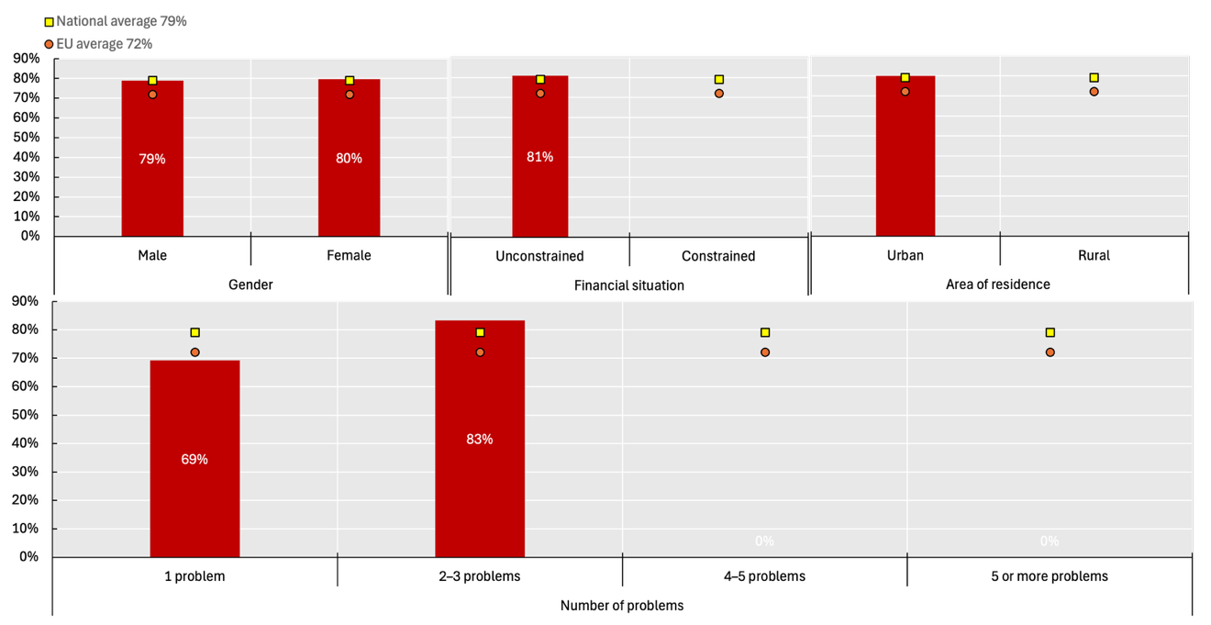
Note: Percentage of respondents who described the resolution process as ‘done with’ and whose justice problem was solved, out of those who experienced a serious justice problem in the previous two years and whose problem resolution process had concluded.
Source: (WJP, 2024_{[2]})

Trust in judges and magistrates
More than half of people in Malta (55%) indicate that they have either ‘a lot’ or ‘some’ trust in judges and magistrates. While this suggests a moderate level of trust in the judiciary, it also points to a significant degree of public skepticism. Trust in judges remains below the EU average of 57%, underscoring a gap between Malta and many other member states (WJP, 2024_{[2]}).
Levels of trust are unevenly distributed across the population. Men report lower trust in judges than women (53% compared to 57%). Financial circumstances also appear to be a particularly strong determinant, as only 35% of those in a constrained financial situation reported trust in judges, compared to 59% among those in a more secure economic position. In addition, prior interaction with the justice system influences perceptions: people who have experienced a serious justice problem report lower trust (50%) than those without such experience (60%) (WJP, 2024_{[2]}).

Trust in prosecutors
Public trust in prosecutors responsible for criminal investigations is lower than trust in judges, with 48% of people experiencing ‘a lot’ or ‘some’ trust. In this area as well, Malta falls fairly short the EU average of 57%, ranking 23rd among member states. The gap becomes particularly evident when comparted to countries with the highest levels of trust in prosecutors, such as Finland (84%), the Netherlands (78%), and Luxembourg (78%).
Patterns of inequality in trust are similar to those observed for judges. People in financially constrained situations report substantially lower trust in prosecutors (33%) than those without such constraints (50%). Similarly, individuals who have previously encountered a serious justice problem express less trust in prosecutors (40%) compared to those who have not had such experiences (54%) (WJP, 2024_{[2]}). Finally, men report lower trust (46%) compared to women (50%).

Trust in public defence attorneys
Trust in public defence attorneys is higher than trust in prosecutors but lower than trust in judges. 53% of people report having ‘a lot’ or ‘some’ trust in public defence attorneys, placing Malta in line with the EU average of 52%.
Similar to patterns observed for other justice actors, trust levels are lower among individuals facing financial constraints (40%) than among those in more secure situations (55%). Prior experience with a serious justice problem is once again associated with reduced trust, affecting 47% of those with such experience compared to 58% among those without (WJP, 2024_{[2]}).

A problem is considered serious when individuals rate its seriousness at four or above on a ten-point scale, signaling that the issue had a genuine and substantive impact on their lives
People in a financially constrained situation are those who answered that money is not enough to cover all their basic necessities and/or clothes when asked to describe their household financial situation.
We consider that an individual has access to appropriate information and advice if they replied that they knew where to get good information and advice about resolving the problem.
Individuals who have attended law school or work for an organisation that provides legal advice
Due to the reduced sample size, we are unable to provide reliable prevalence estimates for each of these concerns.
Due to the reduced sample size, we are unable to provide prevalence estimates for each of these challenges.

